**POWER BI ASSIGNMENT-18**

**Topic –** Charts

**Exercise –** Show a chart comparing filmswhen you click on each genre in a tree map.

Q1. Create a new Power BI report. Load the worksheets from the workbook in the above folder, and use them to create a data model.

Step-1. Load the data in in Power BI and connect all the tables

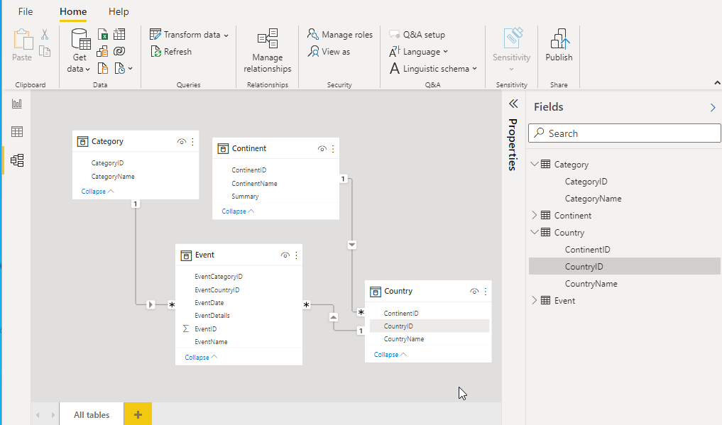

Step-2. Create a year column using YEARDAXFUNCTION as shown below.

Year = YEAR(Event[EventDate])

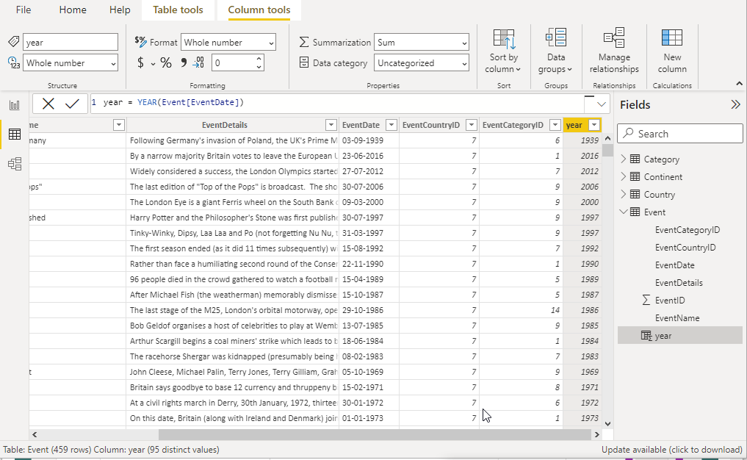

Step-3. Insert table visual and matrix visual as per requirement and filter to Africa continent as shown below.

